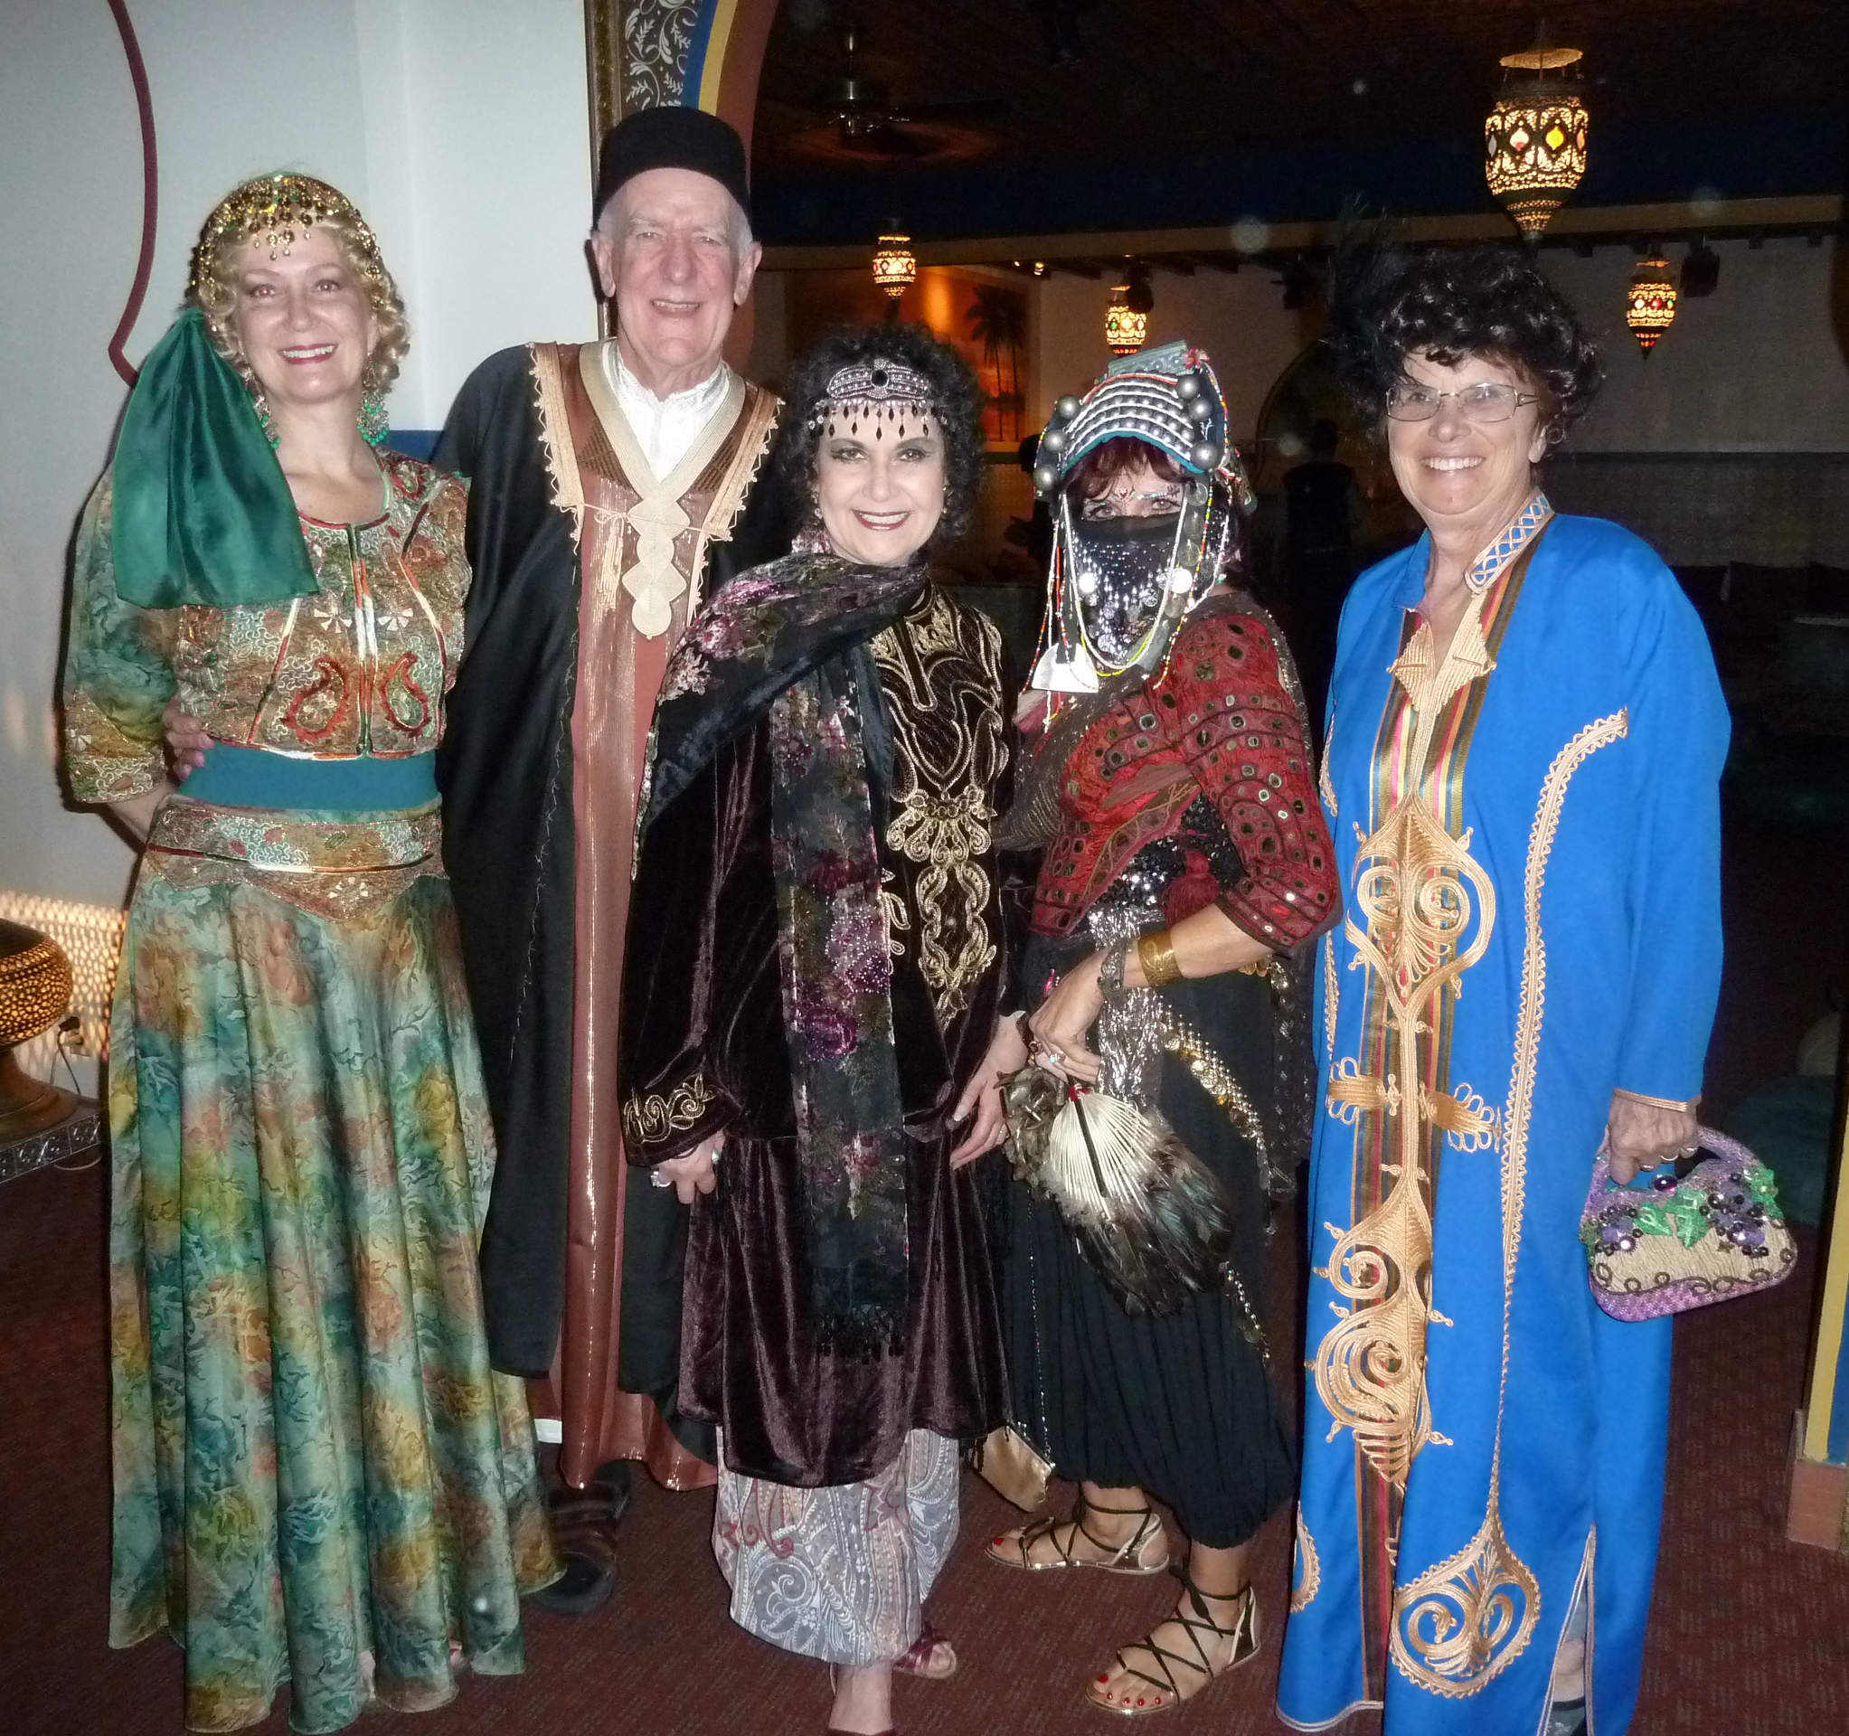  [Photo by xxxxx]  All Our Chapters & SIGs  - Armed Costumers Guild  - Beyond Reality Costumers Guild (Seattle, WA)  - Chicagoland Costumers Guild  - Fibre Fantasy Artists of Canada  - Gem State Costumers (ID)  - The Greater Columbia Fantasy Costumers Guild  - The Greater Delaware Valley Costumers Society  - Miss Lizzy’s Traveling Historical Fashion Show  - NJ/NY Costumers Guild  - Northern Lights Costumers Guild (ME)  - Saint Louis Costumers Guild (MO)  - Silicon Web Costumers Guild (online)  - Southwest Costumers Guild (AZ) |  |  | More About the ICG  About Us  We are an affiliation of amateur, hobbyist, and professional costumers dedicated to the promotion and education of costuming including cosplay as an art form in all its aspects.  International ICG Contacts  Email: info@costume.org  ICG Costume Chat: https://groups.google.com/a/costume.org/g/cos-chat  Facebook: https://www.facebook.com/internationalcostumers  Website: https://costume.org/  Chapter/SIG Name Here |  |  | Chapter/SIG Name Here  - A part of the International Costumer’s Guild

Your ICG Local XXX  Here are a couple of ideas…  This spot would be perfect for a mission statement. You might use the right side of the page to summarize how you stand out from the crowd and use the center for a brief success story.  (And be sure to pick photos that show off what your chapter does best. Pictures should always dress to impress.) |  |  | Think a document that looks this good has to be difficult to format?  Think again! Just type over this paragraph and the style will automatically match the rest of the brochure.  “Don’t be shy! Show them how fabulous you are! This is a great spot for a glowing testimonial about your group.”  Get the exact results you want  Don’t like these colors? This is built on tables so to customize the look of this brochure, go to the on the Design tab of the Table Tools, check out the other options.  How to contact us  Fill in your chapter contact information here. |  |  | [Type a caption for your photo]  Don’t forget to include some specifics about what you offer, and how you differ from the competition.  Why you should join us  Talk about the conventions your members attend. Do you hold workshops or other meetings? Are there special interests your chapter pursues? List that stuff here to entice prospects into finding out more.

